Book 1: Jane & Jake’s Adventures to Awesome Truth

OVERVIEW: Nine-year-old Jane is thrilled. At last she has a real friend at school, Jake. However, when she hears Jake lie—twice!—about her to a boy in their class, she is angry and hurt. Not even Jake’s gift of a prism makes her feel better or want to forgive him. That’s when Oracle, Jane’s talking goldfish and her best friend, whisks both Jane and Jake to the Undersea World of Awesome to become contestants in the To Tell the Awesome Truth game. Will they win the Blue Pearls of Awesome Truth? only if Jane and Jake work together—and discover that they are, after all, True-Blue Friends.
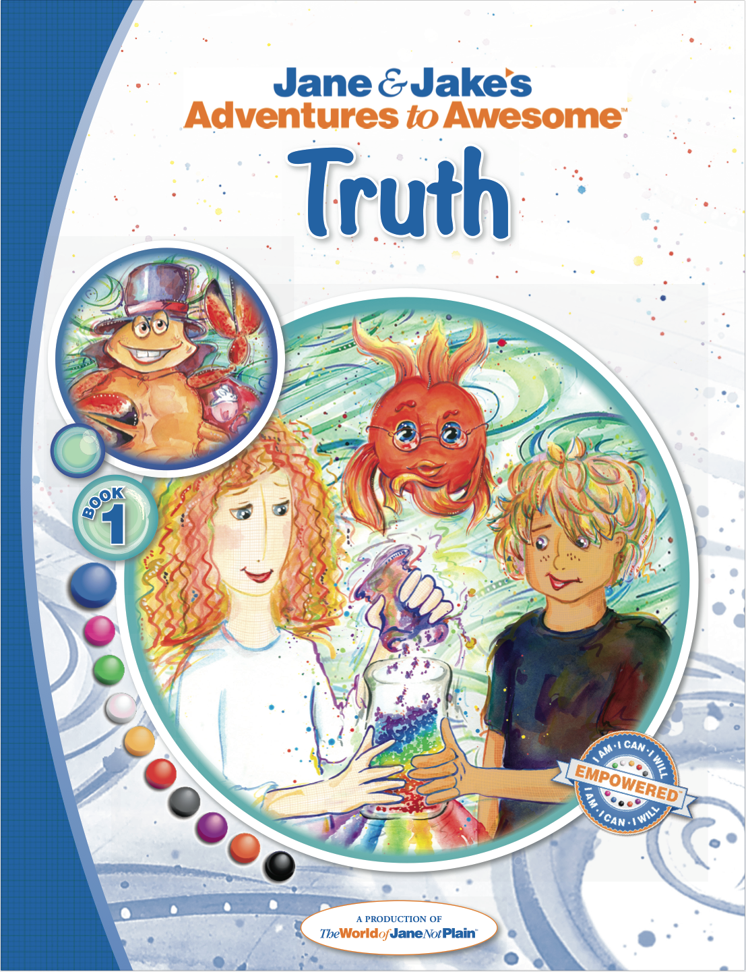
FROM THE BOOK:
- “Bub A Wow, now! Your face looks red-hot angry. Out with it!”
- “He made me mad, Oracle. I was feeling awesome. Then I heard him lie to Max, a kid in our class. Jake said he hadn’t come to our apartment even though he did when he brought back my purples bracelet.”
- Oracle looked at me as if he had superpower eyes that could see inside me. “Maybe you’re also feeling a little hurt.”
- “I crossed my arms across my chest and stared at Oracle. I didn’t want to talk about feeling hurt. I just wanted to yell something at Jake and make him feel bad too.”
PRAISE:
“When I read “Jane & Jake’s Adventures to Awesome Truth” to my 7 year old little brother (who doesn’t sit still), he actually paid attention to Jane & Jake’s Adventures. He was able to tell me the events when we were done and said that he had to tell the truth to be a good friend.”
CREATORS:
Dona Rudderow Sturn, Founder & CEO [Creative Director], United States
Kathy Szaj, M.Ed, Lead Writer, United States
Judy Bartkowiak, Writer, United Kingdom
Jim Westcott, Writer, United States
Children’s Chapter Book, Ages 5-12+ (Prequel in a 31-book series, Jane & Jake’s Adventures to Awesome)
124 pages, illustrated / Publication date: 2014 | Published by The World of Jane Not Plain™ LLC
Soft Print ISBN: 978-1-940979-06-9 Hard Print ISBN: 978-1-940979-07-6 EPUB ISBN: 978-1-940979-08-3
MOBI ISBN: 978-1-940979-09-0 PDF ISBN: 978-1-940979-10-6 iTunes IBA ISBN: 978-1-940979-11-3

