Prequel: Jane & Jake’s Adventures to Awesome: The Journey Begins

OVERVIEW: Jane is glad that Oracle—her smart, talking pet goldfish—is her best friend. But when it comes to having a human friend at school, Jane feels mostly invisible. She’d like to become friends with Jake, a joke-telling boy in her class, but she feels too embarrassed to even talk with him. When Jake kindly finds and returns Jane’s special “purples bracelet” to her, Oracle decides to take magical action. He leaps out of his fishbowl and whooshes Jane and Jake to the fantastic Undersea World of Awesome where they are introduced to their super-power glowing gifts—their inner awesome!
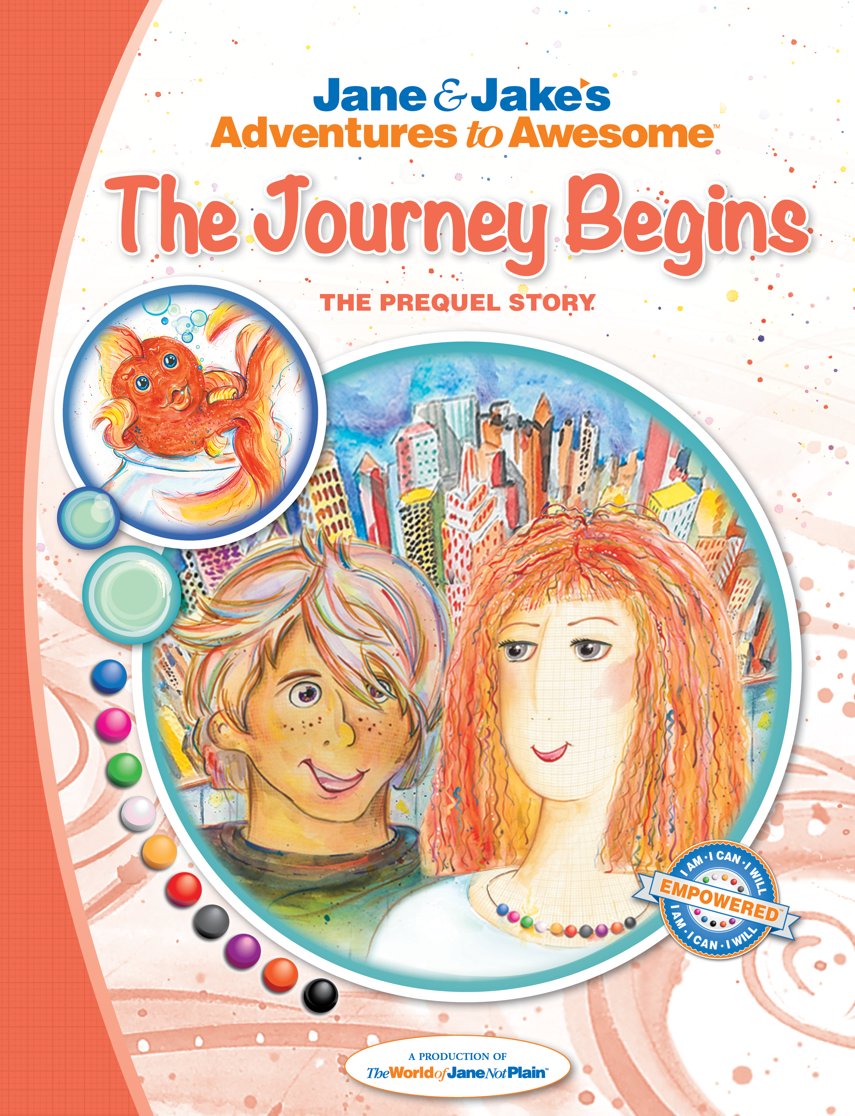
FROM THE BOOK:
- “Just think, Oracle, they’re going to notice me, Jane, and they’ll become my friends…real friends.”
- “Bub A Lo, hey!” said Oracle softly.
- “Human friends, Oracle–at school,” I said. I hadn’t meant to hurt his feelings. My goldfish is my best friend, and I tell him almost everything.
- “This is going to be awesome, Oracle!”
- “Well...” said Oracle loudly, using his fin like a megaphone.
- “Why do you keep saying that, Oracle?” I do love him, but he can be annoying sometimes, especially when he knows something that I don’t.
PRAISE:
“I am a middle school teacher who also organizes a group to promote self advocacy and confidence in young girls. I use these books to support the girls in learning about themselves –– and discussing their points of view and experiences. The girls positively respond to the stories, characters, and artwork, and they are so excited for the next book in the series. Thanks to The JNP Project for helping these girls discover their inner awesome and share it with the world.”
CREATORS:
Dona Rudderow Sturn, Founder & CEO [Creative Director], United States
Kathy Szaj, M.Ed, Lead Writer, United States
Judy Bartkowiak, Writer, United Kingdom
Jim Westcott, Writer, United States
Children’s Chapter Book, Ages 5-12+ (Prequel in a 31-book series, Jane & Jake’s Adventures to Awesome)
92 pages, illustrated / Publication date: 2014 | Published by The World of Jane Not Plain™ LLC
Softcover ISBN: 978-1-940979-00-7 Hard Print ISBN: 978-1-940979-01-4 EPUB ISBN: 978-1-940979-02-1
MOBI ISBN: 978-1-940979-03-8 PDF ISBN: 978-1-940979-04-5 iTunes IBA ISBN: 978-1-940979-05-2

