Book 2: Jane & Jake’s Adventures to Awesome Kindness

OVERVIEW: Jane is furious. First, her art smock is deliberately splotched with pink paint. Then someone pours liquid on her beautiful painting that she is making for the school art fair. Jane suspects that Mia—an older, fifth-grade girl—and Mia’s friends are the culprits. Then, when Mia says horrible, stinging words about the gift Jane’s mom sent to Jane, Oracle whisks Jane and Jake to Awesome, where they discover the challenge that awaits them. To earn their Pink Pearls of Awesome Kindness they must find and return important items lost by their sea creature friends—including the special stinger of Jell-ee-o, a tiny sea jelly. But…how can Jane and Jake return a jellyfish’s stinger without getting hurt?
FROM THE BOOK:
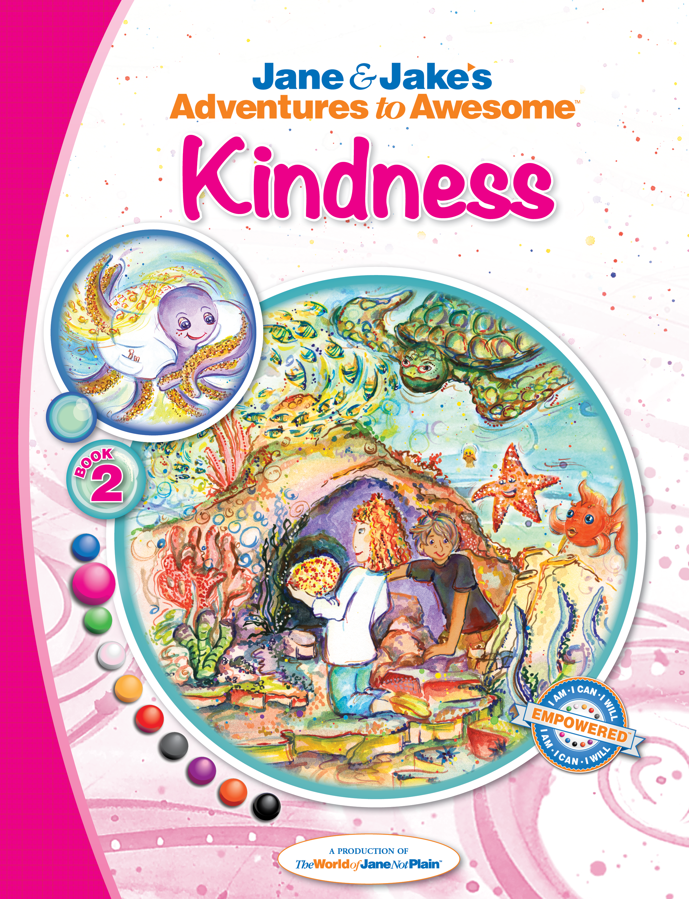
- “Jaunty, whose eyes were closed as he listened to the conversation, opened them widely. “Oracle, I believe that Jane and Jake are worried they will get stung if they find and return Jell-ee-o’s special nematocyst. Am I right, Jane and Jake?” They nodded. “We’re sorry, Jell-ee-o, but those stings really hurt,” said Jane to the tiny sea jelly.
- “Yeah, ouch,” said Jake, looking at Oracle.
- “I understand perfectly,” Oracle nodded.
- “You do?” said Jane. Jake sighed with relief.
- “Sure. Getting hurt is not fun. But that means we’ll need to return home without the next Pearls of Power, the Pearls of Awesome Kindness.”
- “Kindness?” asked Jake. “You mean like being nice to someone even if you feel crabby?”
- “That’s a part of kindness, Jake,” said Jaunty with his wide, sea turtle smile. “And there’s more.”
PRAISE:
“This series is AMAZING! All three of my kids (1 boy/2 girls) love to read the stories over and over! I am getting the Parent Activity kit from the website which supports this book’s theme of KINDNESS! My kids are already excited that they have earned their PINK KINDNESS PEARL OF POWER! Thanks JNP for creating this incredible tool to empower my children!“
CREATORS:
Dona Rudderow Sturn, Founder & CEO [Creative Director], United States
Kathy Szaj, M.Ed, Lead Writer, United States
Judy Bartkowiak, Writer, United Kingdom
Jim Westcott, Writer, United States
Children’s Chapter Book, Ages 5-12+ (Prequel in a 31-book series, Jane & Jake’s Adventures to Awesome)
132 pages, illustrated / Publication date: 2014 | Published by The World of Jane Not Plain™ LLC
Soft Print ISBN: 978-1-940979-12-0 Hard Print ISBN: 978-1-940979-13-7 EPUB ISBN: 978-1-940979-14-4
MOBI ISBN: 978-1-940979-15-1 PDF ISBN: 978-1-940979-16-8 iTunes IBA ISBN: 978-1-940979-17-5

