Facts About The JNP Project™ (“Jane NOT Plain”) and “Jane & Jake’s Adventures to Awesome”

- MISSION STATEMENT: JNP is a JNP is a positive self-esteem movement that promotes the growth of character, courage, and confidence in boys and girls (5-12+) by helping them discover and make choices from their inner-awesome superpowers.
- BRAND VISION: I AM. I CAN. I WILL. EMPOWERED.TM
- BRAND SPIRIT: Discovering your inner awesome is positively empowering!
- MISSION PHILOSOPHY: The World Needs You! Own It.TM
- ACTION: The JNP Project is an advocate, empowering agent, and helper*
- We advocate healthy self-esteem awareness and development in kids (unlike the inflated “high self-esteem” attributed to bullies).
- We empower kids to be “inner awesome”: to know, trust, and choose to act from their character, courage, and confidence (key ingredients of healthy self-esteem).
- We help adults who care deeply about kids—especially parents, educators, and helping professionals—to nurture and strengthen kids’ inner-awesome character, courage, and confidence through the core values of truth, kindness, harmony, forgiveness, giving, love, determination, compassion, and strength.
* “When I was a boy and I would see scary things in the news, my mother would say to me, ‘Look for the helpers. You will always find people who are helping.’ ”—Fred Rogers
- JNP builds around empowerment, not entitlement, sharing with parents the tools that empower children to do for themselves instead of expecting things to be done for them.

- The movement is anchored by a colorful and engaging series of chapter books entitled Jane & Jake’s Adventures to Awesome. The books are supported by a highly interactive website packed with resources for parents, grandparents, nannies and au pairs, school educators, religious education directors and teachers, school counselors, helping professionals, and organizations.
- The Jane & Jake’s Adventures to Awesome series begins with one introductory Prequel book followed by 30 themed stories divided into three series:
Series One: Character Traits
Series Two: I Am / I Can
Series Three: I Will – EMPOWERED.
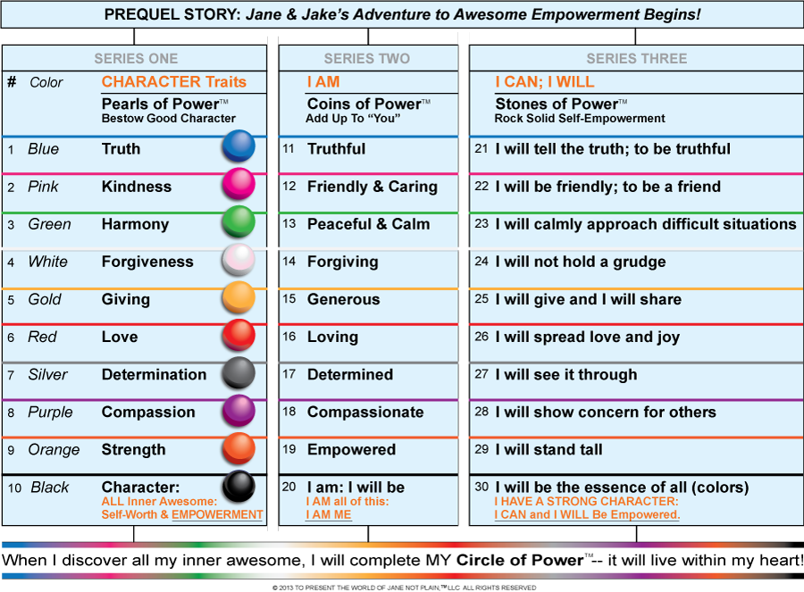
- In each book, readers are challenged to discover their Me as they earn a Pearl of Power™ in one of JNP’s ten core values (inner-awesome superpowers): TRUTH, KINDNESS, HARMONY, FORGIVENESS, GIVING, LOVE, DETERMINATION, COMPASSION, STRENGTH, and CHARACTER.
- A MAIN FOCUS OF THE JNP CHARACTERS is that the lead characters Jane (who is NOT plain) and Jake (her true blue friend) were developed to be outer “blank canvases” through which kids’ inner-awesome “colors”—their emotions, gifts, and values—shine through.
- The books––colorful and intricately designed with three endings (Jane’s, Jake’s and Oracle’s), enable a child to choose his or her favorite ending. These fun adventures encourage empowerment and teach kids to reach within themselves, making important decisions from their inner awesome.

- Spring-boarding from the values presented in the books, the JNP Project is the creator of the Boomerang It! Challenge. This program challenges all of us to initiate good acts around one of the ten core Jane & Jake values including truth, kindness, harmony, forgiveness, giving, love, determination, compassion, strength, and character.

- As a complement to the book series, JNP provides Parents and Educators with separate Resource Kits with age-appropriate explanations of each core character theme, outlined lessons, suggested activities and solutions to issues, how to communicate with children, Q&A outlines to discuss with children, and more. Each kit has been carefully written for a specific age group.

- The website, www.theJNPproject.com, features fun information and resources for kids to help them learn about their Inner Awesome including activity pages, game ideas, the Circle of Power Empowerment Badge, songs and sheet music, and Jake’s Jokes for kids. A paid subscription, JNP’s Kids’ CIA (Club Inner Awesome) entitles users to new downloadable materials monthly along with the opportunity to directly Talk to Jane and Jake through an interactive forum.

- After children complete the first series of books, they earn their Pearls of Power – My Circle of Power (Empowerment Badge)––a reminder of their accomplishment that continues to live within their hearts. This accomplishment lives on through their developing sense of self-confidence and self-esteem…I AM. I CAN. I WILL. EMPOWERED™.

