FOR IMMEDIATE RELEASE

GOT EMOTIONS?
STORIES FOR KIDS TO EXPLORE THEIR “INNER-AWESOME COLORS”

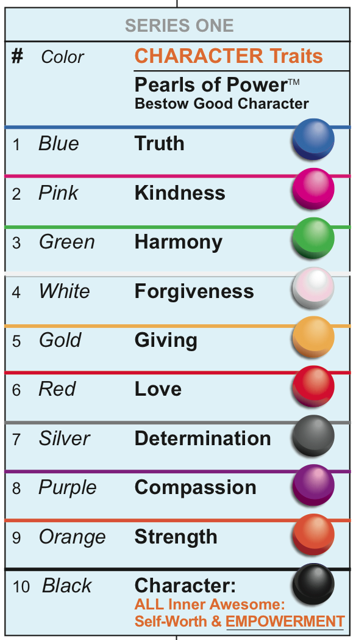
ANNAPOLIS, MD (August 6, 2015) A goldfish that talks about emotions? Yes, when the goldfish is named Oracle, nine-year-old Jane’s oh-so-smart pet and one of the stars in The JNP Project’s illustrated children’s chapter book series, Jane & Jake’s Adventures to Awesome. Yes, when that same goldfish can help kids learn that feeling “sad, bad, mad, or glad”—and all the emotional “colors” in between—are a P.R.I.M.E (Perpetual Rainbow Inside My Emotions) part of their “inner awesome.”
“Each of us has an amazing canvas of emotions,” said Dona Rudderow Sturn, founder and CEO of The JNP Project. Ms. Sturn, who is also an artist, explained further: “At JNP, we believe that all the ‘colors’ that make our inner-awesome sparkle are complimented by our emotional palette. Each of us is the essence of a masterpiece.”
But why talk about emotions? Aren’t they just the way people (and maybe animals) feel? What’s the big deal?
Emotions are a huge deal, it turns out. Unless children begin to learn at an early age to identify, take charge of, and appropriately express their emotions, experts say, kids may have problems in memory, creativity, academic performance, and self-esteem. An evidence-based movement to integrate social-emotional learning (SEL) practices within school culture and curriculum has grown exponentially since the 1990s when psychologist Daniel Goleman popularized “emotional intelligence.”
But learning about, much less welcoming, emotions is complex. The JNP Project recognizes that the inner-awesome colors of kids includes a huge array of emotions. The Annapolis-based company is passionately committed to giving kids (and the adults who love, teach, and care for them) powerful tools and resources to help identify and positively direct their emotions—including Oracle, the often rhyming goldfish: “Now feel your feelings /True and strong/And follow the tune/Of Awesome’s song./Bub A Lo, Home!”
The JNP Project recommends some “tips, tools, and treats” to help kids—and adults—to make friends with their emotions (especially the difficult ones):

- Challenge yourself: How quickly can you find the sixteen emotions hidden in this free JNP Emotions Word Search puzzle?

- Check out the colorful and charming animated emotions in the recently released Disney-Pixar film, Inside Out. For many kids, eavesdropping on the conversations and reactions of eleven-year-old Riley’s inner emotions (anger, disgust, fear, joy, and sadness) may be an introduction to their “inside” energy that finds its way “out.”

- Distinguish and name your specific emotions with the help of an “Emotions Color Wheel.” Click on any one of the many emotions, and a definition, description, etymology, and a face expressing that emotion will helpfully appear below the wheel.

- Use a simple three-step process to calm emotional turmoil. The Committee for Children’s Second Step program recommends: a. Catch yourself while feeling a negative emotion and prevent its escalation by using words such as “Stop!” or “Chill-pill time”; b. Identify the specific emotion you are feeling (“I’m angry” rather than the vague “I’m upset”); c. Diffuse your emotion through deep “belly breathing,” counting, or positive self-talk (“I’m doing fine,” “I can take it easy now”).

For more carefully curated, practical resources to learn about emotions and SEL, see The JNP Project’s special Got Emotions? Tips, Tools and Treats Resources webpage and sign-up for JNP’s free Awesome News, which is e-mailed bi-weekly.

About The JNP Project
The JNP Project is a positive self-esteem movement that promotes the growth of character, courage, and confidence in boys and girls by helping them discover and make choices from their inner awesome. The JNP Project combines original artwork and design with proven teaching methods and outstanding storytelling for girls and boys, ages 5-12+, in an illustrated chapter-book adventure series, Jane & Jake’s Adventures to Awesome.

# # #

Media Contact
Dona Rudderow Sturn
The JNP Project
dona@thejnpproject.com
410-224-3878

